Anthony Panecasio  Level Designer & Team Lead |  | anthony@panecasio.com  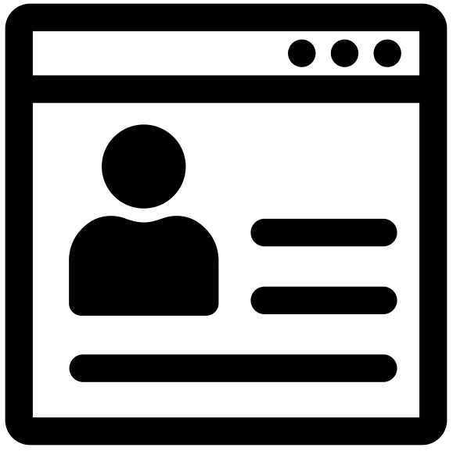 panecasio.com  linkedin.com/in/panecasio  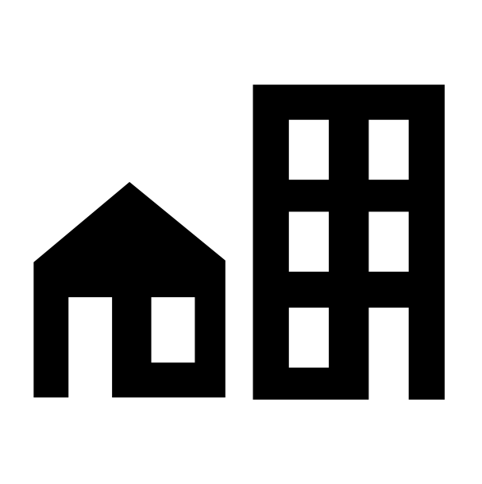Toronto, Ontario, Canada
Work Experience  Team Lead Level Designer  Ubisoft Toronto (Oct 2022 - Present)  Lead a team of 5 LDs to create single-player missions for a third-person action adventure game. Work across departments to develop processes and plan the project.  Senior Level Designer  Ubisoft Toronto (Feb 2022 - Oct 2022)  Pitch and develop single-player mission content for a third-person action adventure game. Collaborate across departments to request and integrate content.  Senior Level Designer  Alpha Channel Games (Oct 2020 - Feb 2022)  Prototype layouts and features, write narrative and mission content, model and animate placeholder props for use in the game world.  Advanced Level Designer  Certain Affinity Toronto (Apr 2020 - Oct 2020)  Create level tile geometry and pitch missions and objectives that combine level tiles into exciting play spaces for 1-4 players in a third-person action game.  Previous Experience  Game Designer  Ubisoft Toronto (Jan 2019 - Apr 2020)  Senior Level Designer  Ubisoft Toronto(Aug 2016 - Jan 2019)  Level Designer  Ubisoft Toronto(Sept 2013 - Aug 2016)  Embedded Development Tester  Ubisoft Toronto (Jun 2012 - Sept 2013)  For details on the roles above, visit my LinkedIn profile. |  | Shipped Projects  Far Cry 6 (2021)  Far Cry 5 (2018)  Watch Dogs 2 (2016)  Assassin’s Creed Unity (2014)  Splinter Cell Blacklist (2013)
Core Skills
Blockmesh Layouts, Visual Scripting, Documentation, Pitching, Prototyping, Pre-vis, Process Development, Project Planning,
Team Tasking, Mentorship
Game Editor Experience
Ubisoft Snowdrop, Dunia, Disrupt, and Anvil
Unreal Editor 4 and 5
Software
JIRA, Confluence, MIRO, Figma, Perforce, Adobe Photoshop, Adobe Premiere, 3DS Max, Blender
Features on GameDeveloper.com
• Learning Basic Fluency In Dark Souls
3's Cemetery of Ash
• "Man Versus Machine" Watch Dogs 2
Level Design Breakdown
Education
McMaster University (2007 - 2011)
B.Eng, Software Engineering (Candidate)
Interests
Running, Hiking, Graphic Design, Reading

